UNIVERSITY OF SCIENCE - VNUHCM
FACULTY OF INFORMATION TECHNOLOGY
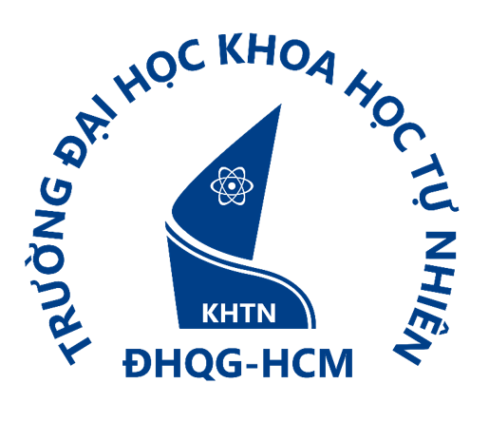
OBJECT-ORIENTED PROGRAMMING REPORT
SUBJECT: MANAGEMENT SYSTEM APPLICATION

Instructor:
Võ Nhật Tân
Trương Tấn Khoa
Students:
Huỳnh Phúc Nguyên
Đỗ Minh Khang
Nguyễn Viết Bách
Lâm Hồng Hải Hoàng Lê
Dương Anh Hào

ACKNOWLEDGEMENTS

GROUP INTRODUCTION

General information

Group ID: 01
Student ID | Full Name | Email
25127106 | Huỳnh Phúc Nguyên | hpnguyen2527@clc.fitus.edu.vn
25127045 | Dương Anh Hào | dahao2532@clc.fitus.edu.vn
25127207 | Lâm Hồng Hải Hoàng Lê | lhhhle2508@clc.fitus.edu.vn
25127275 | Nguyễn Viết Bách | nvbach2517@clc.fitus.edu.vn
25127363 | Đỗ Minh Khang | dmkhang2525@clc.fitus.edu.vn

Member roles and task assignments

Full Name | Assigned Tasks | Contribution (%)
Huỳnh Phúc Nguyên
Dương Anh Hào
Lâm Hồng Hải Hoàng Lê
Nguyễn Viết Bách
Đỗ Minh Khang

PROBLEM STATEMENT

Selected management topic

Target Users

Main features

Input and output data

SYSTEM DESIGN

PROJECT ARCHITECTURE

IMPLEMENTATION AND TESTING

AI USAGE AND INDIVIDUAL ACCOUNTABILITY

CHALLENGES AND FUTURE ENHANCEMENTS

REFERENCES

APPENDICES

